AKSA Instrument Spec Database User’s Guide

Overview 2
Opening the Application 2
Finding an Instrument 4
Initial Filters 4
Additional Filters 5
Voided Instruments 6
Selecting a Spec Form 7
Viewing an Instrument Spec 8
Printing an Instrument Spec 9
Editing an Instrument Spec 12
Modifying Specification Data 12
“Voiding” an Instrument 14
Updating Revision Information 15
Adding an Instrument 18
Manually Entering an Instrument Specification 21
Copying an Instrument Specification 23

Overview
The AKSA Instrument Spec Database provides a convenient, web-based interface for viewing, printing and maintaining process instrumentation specifications. This document describes the procedures for opening the application, finding the desired instrument spec for display and hard-copy, editing an existing specification and adding a new instrument to the database.

Opening the Application
A link to the Instrument Spec Database is located on the AKSA intranet home page under the “Maintenance” header (Figure 1).

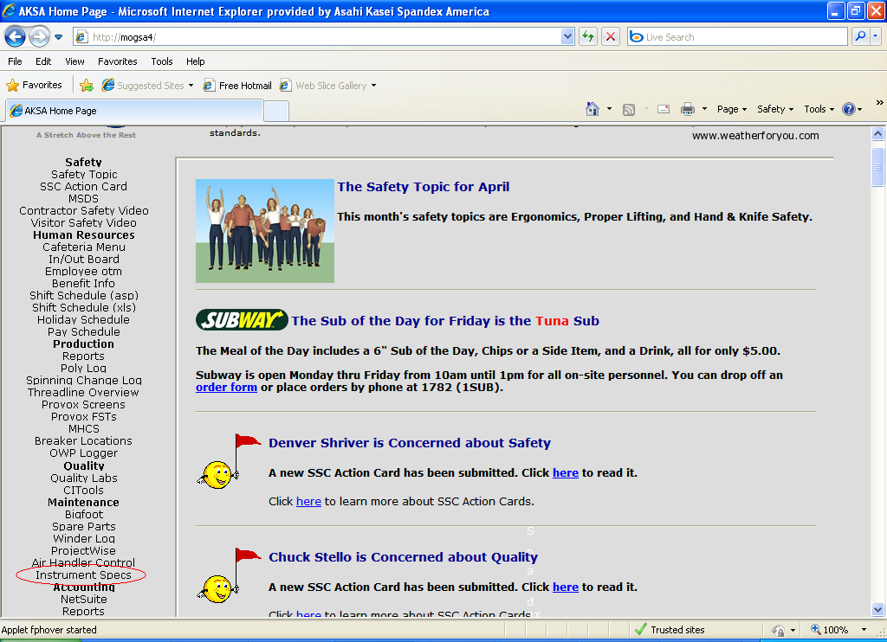
Figure 1

Clicking this link will display the application main menu. Items on this page may or may not be displayed, based on the user’s permission level. For example, a technician who only needs to be able to view and print spec sheets would only be given a limited number of options (Figure 2), but an engineer or maintenance supervisor who has responsibilities for maintaining specification data would have more options (Figure 3).

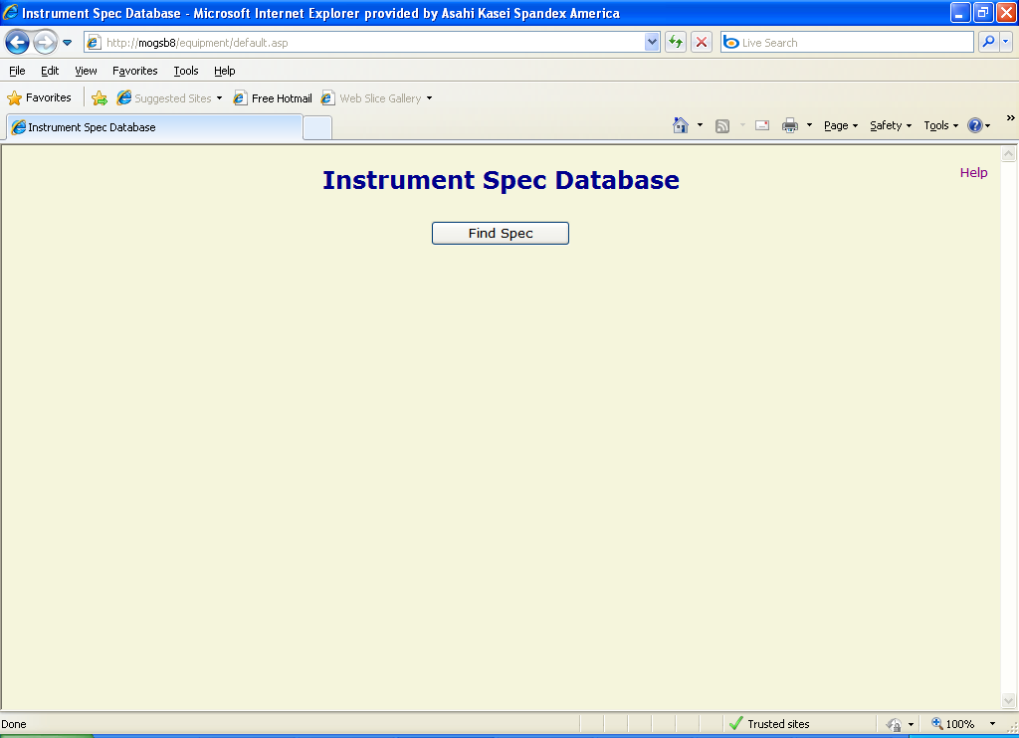
Figure 2

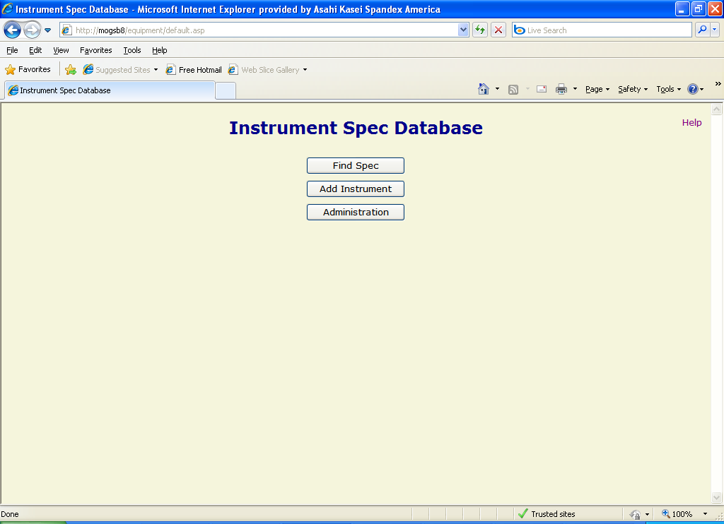
Figure 3

Finding an Instrument
The application provides an extensive filtering system to allow users to select an instrument spec to display or print. Clicking the “Find Spec” button from the main menu opens the “Select Instrument” Form (Figure 4). This form allows the user to supply search criteria to easily find the instrument spec desired.

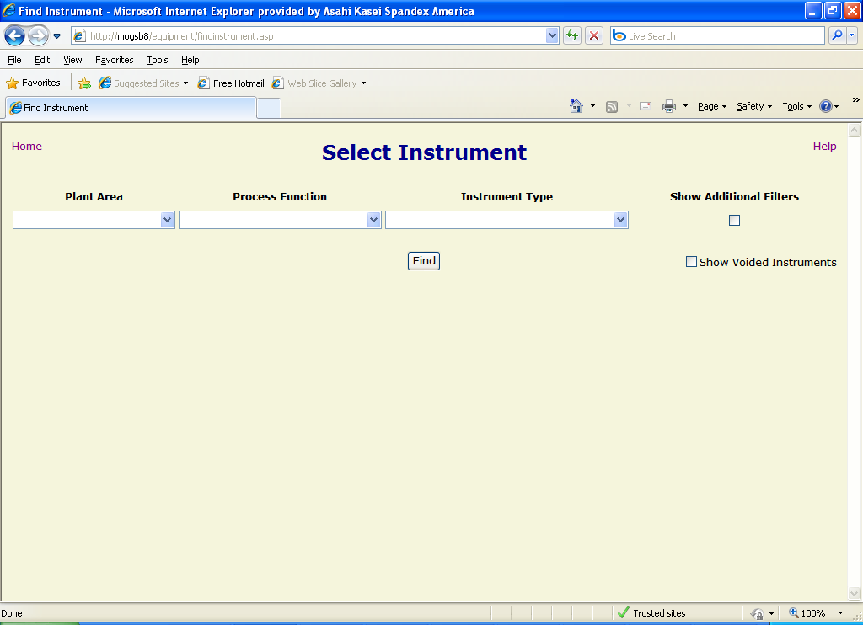
Figure 4

Initial Filters
The initial screen presents three filter selections in dropdown lists. In some cases clicking on an item in one of these lists causes the application to re-query one or more of the other lists to limit the choices to correspond to the item selected. While the page is being redrawn, the message “Please Wait…” is displayed in the upper left corner.

- Plant Area – the process area to which the instrument is assigned (e.g. Area-0230). Selecting an item from this list limits the “Equipment”, “Line”, “Loop” and “Location” lists (see Additional Filters below).
- Process Function – the process parameter to which the instrument is related (e.g. pressure, temperature, etc.). Selecting an item from this list limits the “Instrument Type” list.
- Instrument Type – the task that the instrument performs (e.g. flow indicator, flow alarm, etc.)

Additional Filters
If the user desires, other criteria may be specified to further reduce the number of items returned. These items are revealed by clicking the “Show Additional Features” checkbox. NOTE: It is recommended that the user first select a “Plant Area” before picking this option in order to speed up the page display. This action provides four additional dropdown lists (Figure 5). Clicking the checkbox again hides these fields.

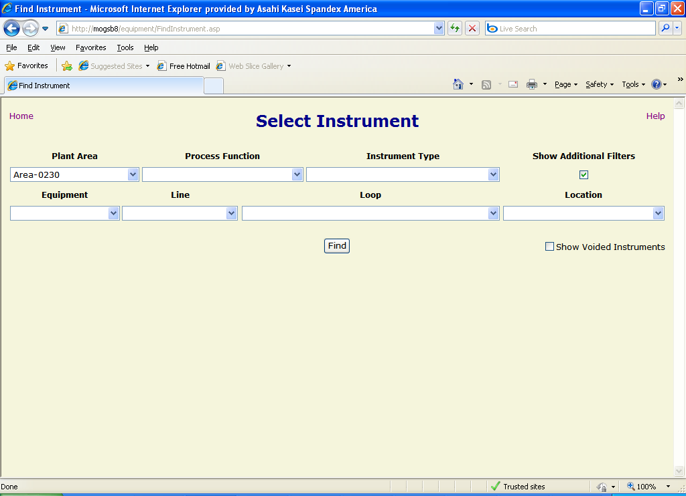
Figure 5

- Equipment – the name of the equipment to which the instrument is associated (e.g. 0230-00-15-152).
- Line – the name of the process piping with which the instrument is associated (e.g. 004-01-C4A28-1-1/2”).
- Loop – the name of the process loop to which the instrument is associated (e.g. A-0230-55001).
- Location – the plant location where the instrument is positioned (e.g. 2F, C-D, 9-10).

When all of the filter criteria have been specified, click the “Find” button to view the matching results (Figure 6). The items returned will have to meet each of the conditions selected. For the example in the figure, the instruments shown in the list box are all assigned to area 0230 and to equipment 0230-00-22-687. The result list box displays the instrument name and description and the spec form number that (if any) that has been assigned to the instrument.

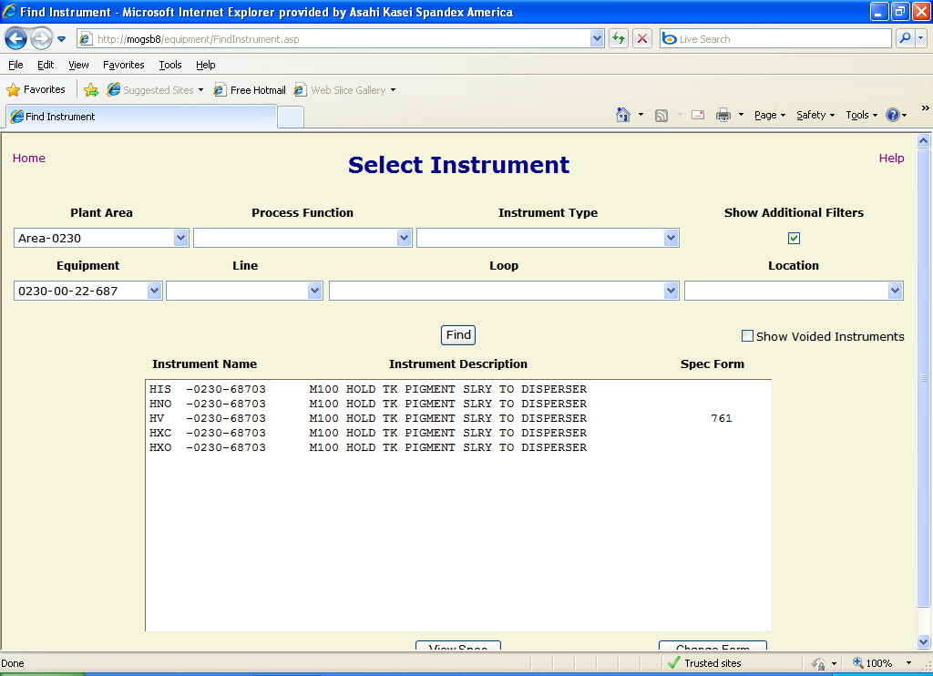
Figure 6

Voided Instruments
By default, the “Select Instrument” form only allows users to select “active” instruments. To include items that have been “voided” (i.e. removed from active service or inactivated due to error), click the “Show Voided Instruments” checkbox. The page will refresh and display both active and inactive items that meet the filter criteria. Clicking the checkbox again toggles this option off.

Selecting a Spec Form
From the “Select Instrument” form, either double-click on the desired instrument in the result list box, or single-click on it and click the “View Spec” button. If a spec form has not already been assigned to the selected instrument, a screen will be displayed to allow the user to choose one (Figure 7). Likewise, if the user wishes to change the spec form assigned to an instrument, he/she may click on the item in the result list box on the “Select Instrument” form, then click the “Change Form” button.

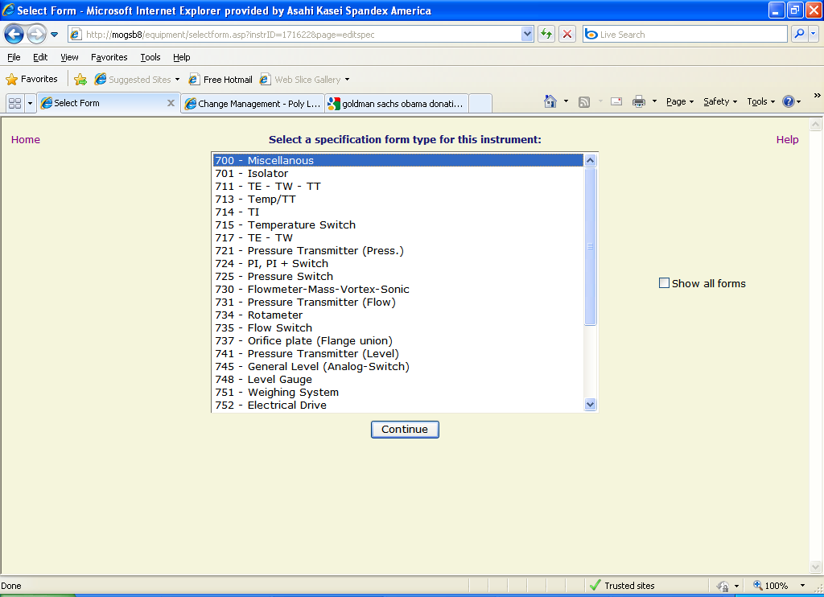
Figure 7

By default, the “Select Form” page only displays typically used spec forms. To see the full list of available forms, click the “Show all forms” checkbox and the page will be refreshed with all items visible. Clicking the checkbox again will toggle the list back to the “typical” list.

To view the previously selected instrument in a particular spec form, click on the desired form in the list and click the “Continue” button. The chosen form will be assigned to the instrument so that this step will not be necessary in the future.

Viewing an Instrument Spec
Clicking the “View Spec” button on the “Find Instrument” form or the “Continue” button on the “Select Form” form brings up the assigned spec form for the selected instrument (Figure 8).

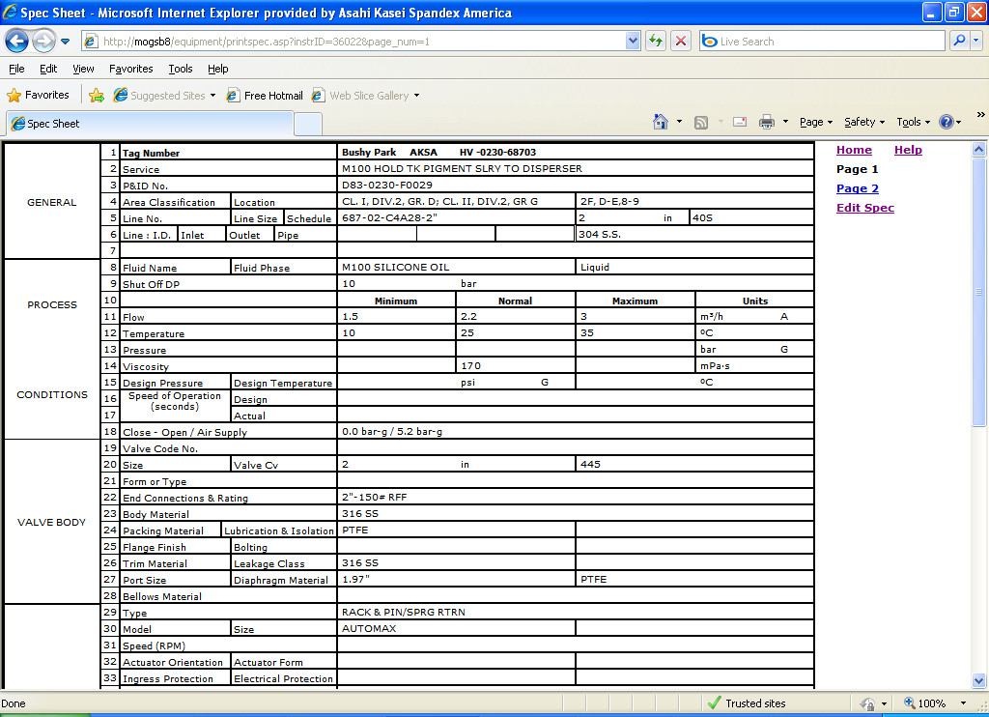
Figure 8

Several links are displayed to the right of the spec form:

- Home – Clicking this link will return the user to the Instrument Spec Database Main Menu.
- Page # – These links provide a method to move between pages of a multi-page spec form. The page that is currently displayed is shown in static black text instead of a link.
- Edit Spec – This link is only displayed if the user has sufficient privilege to edit instrument specifications. Clicking it will display the “Edit Spec” form.

Printing an Instrument Spec
To print a spec, the user opens it in view mode and uses the browser’s print functionality to actually produce the hard-copy. Unfortunately, the default print settings for most browsers specify header and footer information and rather wide margins. The following procedure describes the steps to print the spec in a more readable and professional form. NOTE: This procedure only applies to Microsoft Internet Explorer versions 7.0 and higher.

- Open the instrument spec in view mode (see Viewing an Instrument Spec above).
- From the browser’s “File” menu, select “Print Preview…” The page will be displayed the way that the browser will print it (Figure 9).

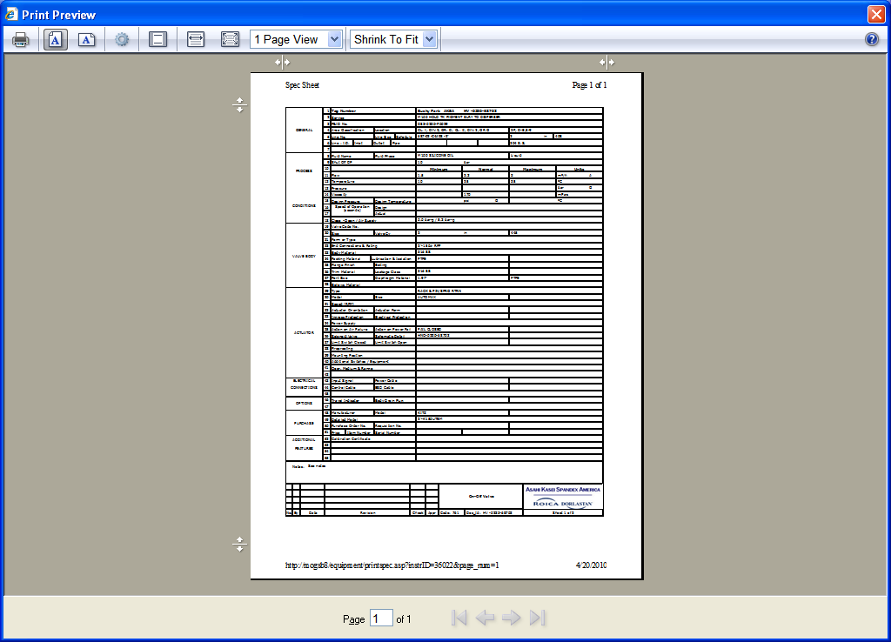
Figure 9

- On the Print Preview toolbar, click on the “Page Setup” button (Figure 10) to bring up the “Page Setup” dialog box.

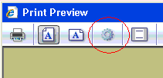
Figure 10

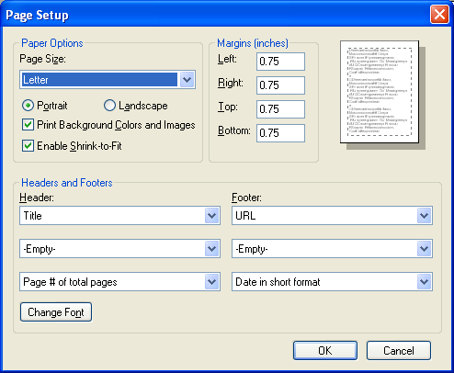
Figure 11

- On the “Page Setup” dialog (Figure 11), make the following changes:
  - Change all of the margins to 0.25.
  - Change all of the Header and Footer dropdowns to “-Empty-”.
  - Click the “OK” button to close the dialog.
- The Print Preview page will refresh to show the spec form covering more of the page (Figure 12).
- To send the spec form to the printer, click the “Print” button on the Print Preview toolbar (Figure 13) to open the “Print” dialog box.
- In the Print dialog, select the appropriate printer, then click the “Print” button.

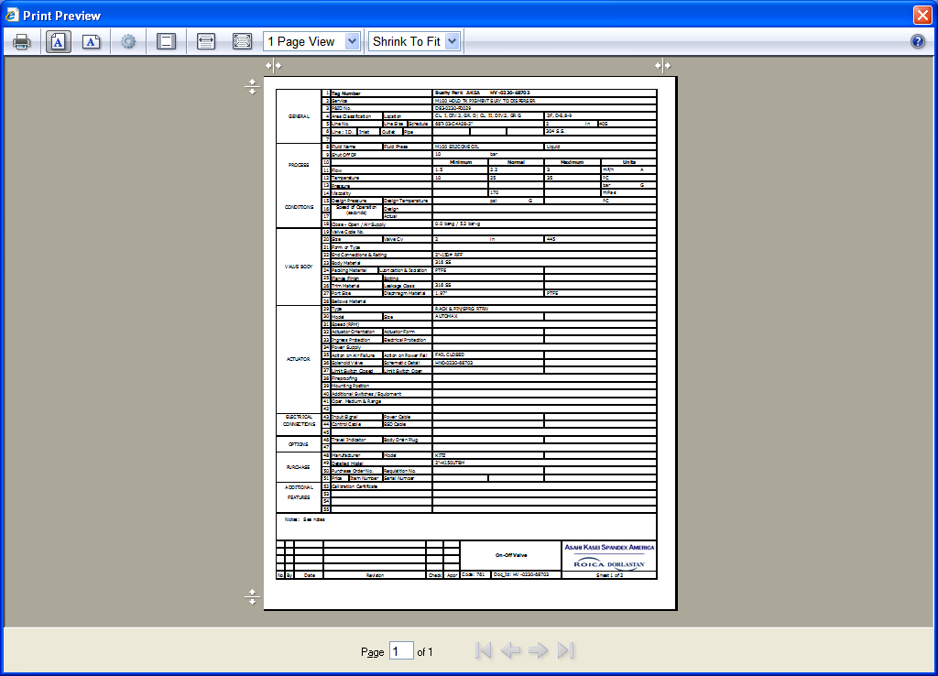
Figure 12

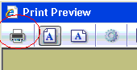
Figure 13

Editing an Instrument Spec
If a user has been given the appropriate permissions, he/she can make changes to existing instrument specification data using the “Edit Spec” form (). This form is accessed by clicking the “Edit Spec” link on the “View Spec” form (see Viewing an Instrument Spec above). It allows users to save changes to the specification data, “void” the instrument, and modify the revision information for the instrument.

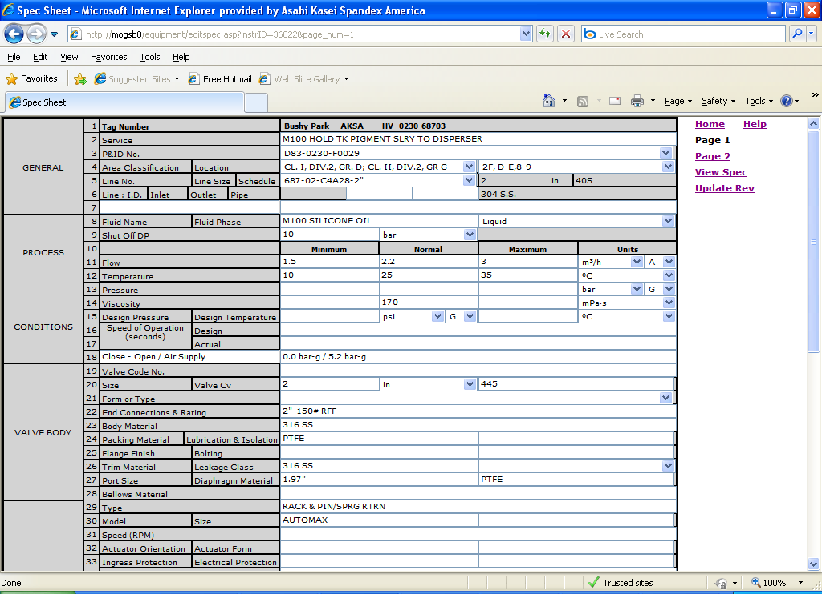
Figure 14

Modifying Specification Data
The Edit Spec form contains five kinds of data fields to allow display and/or modification of the specification data:
- Static text – These are non-modifiable fields that display data about the base instrument itself, like the tag number, or about a parameter that has been specified for the instrument, like the line number. In the latter case, the data on the form may update when a new value is selected for the parameter. For example, the line size and schedule may change when a new line number is selected.
- Textbox – These are single-line text fields that allow users to modify data through standard typing techniques (highlight, backspace, delete, etc.). They may contain either instrument spec data or spec form customizable fields.
- Text area – A multi-line text field that allows users to enter a virtually unlimited amount of data (although the database field is limited to 2000 characters). This field is also modified using standard typing techniques.
- Dropdown list – These fields allow users to select an entry from a pre-defined list to simplify data entry and provide data consistency. The user simply clicks on the down-arrow beside the field, scrolls through the resulting list of values, and then selects one by clicking it. In some cases, selecting a new value may result in a form refresh so that data associated with the selected value can be displayed. When this occurs, the message “Please Wait…” will be displayed until the refresh is complete.
- Checkbox – This allows easy entry for yes/no type of data. When the check is displayed the value is “Yes”, when it is not displayed the value is “No”. The user toggles between checked and unchecked by clicking on the box.

In order to save the specification changes that have been made to the database, the user must click the “Save” button at the bottom of the form (Figure 15). Clicking this button will cause the form to display “Please Wait…” while it writes any changed values to the appropriate database fields.

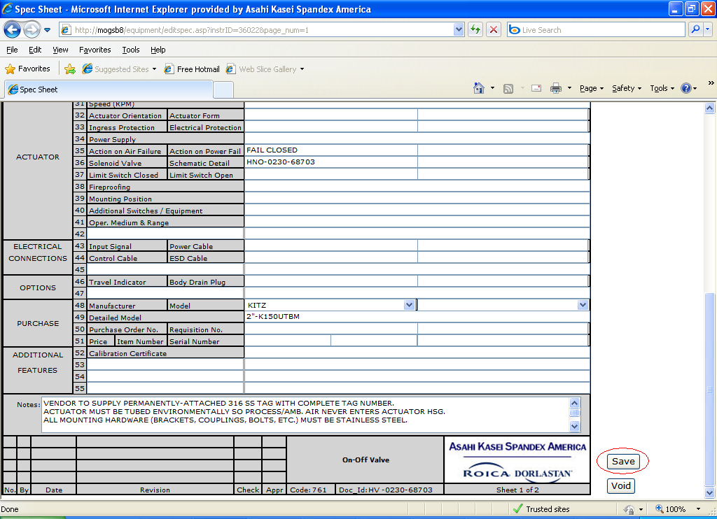
Figure 15

If the user attempts to move to a different page or to close the browser before saving any changes, a pop-up message will be displayed warning that the changes will be lost (Figure 16). To keep the changes, click the “Cancel” button on the pop-up and then click the “Save” button on the “Edit Spec” form. To discard the changes, click the “OK’ button on the pop-up.

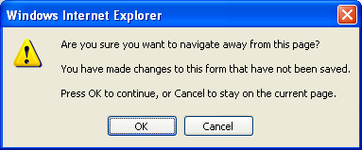
Figure 16

“Voiding” an Instrument
When an instrument is removed from service or when an instrument has been entered incorrectly such that it cannot be corrected by editing, its specification should be “voided” to remove it from active status. This has the effect of excluding the instrument from the results when a user is searching for an instrument (see Voided Instruments above). To accomplish this, click the “Void” button at the bottom of the form (Figure 17). A confirmation message (Figure 18) will be displayed. Click the “OK” button on the message to continue voiding the instrument or the “Cancel” button to stop the action.

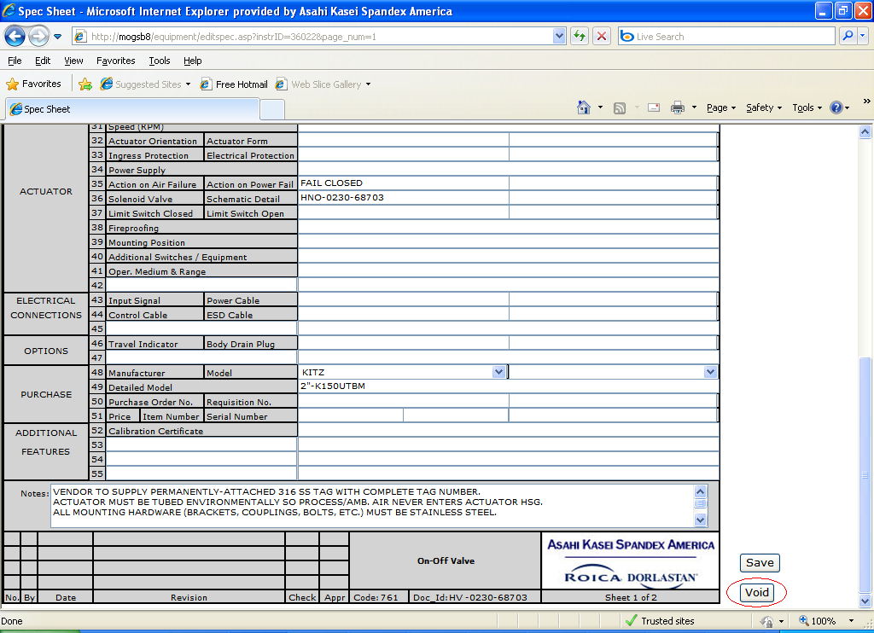
Figure 17

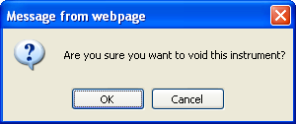
Figure 18

Once an instrument is voided, the spec form appears with the word “Voided” across it (Figure 19) and the “Void” button is changed to “Un-Void”. Clicking this button allows the action to be reversed and the instrument to be placed back to active status.

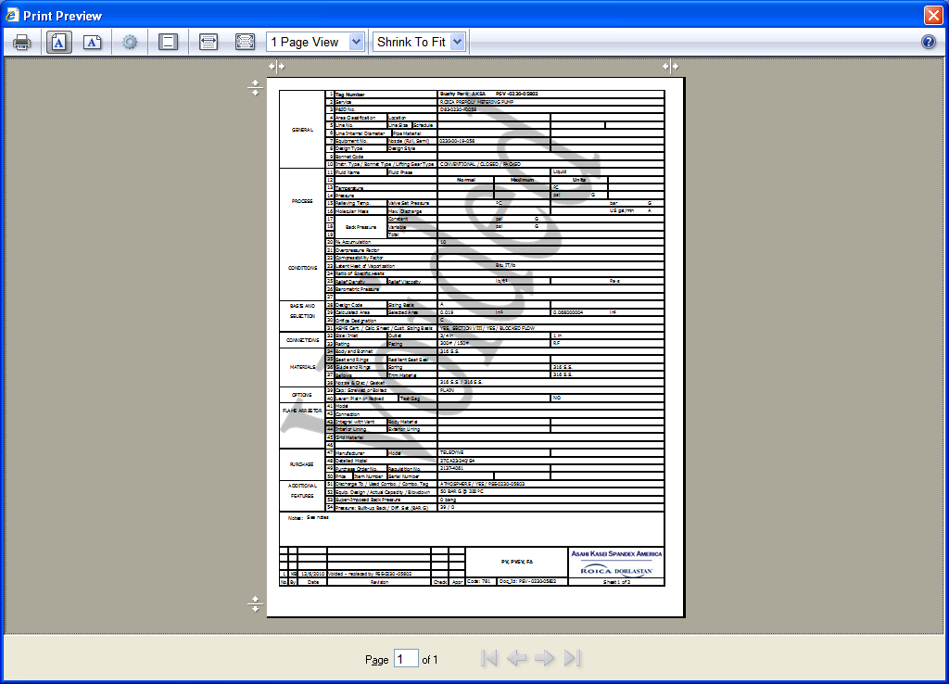
Figure 19

Updating Revision Information
It is the responsibility of the person making changes to an instrument specification to maintain the information about the changes made. To accomplish this, click on the “Update Rev” link (Figure 20) on the “Edit Spec” form. This opens a pop-up window that allows the user to enter and save revision data (Figure 21).

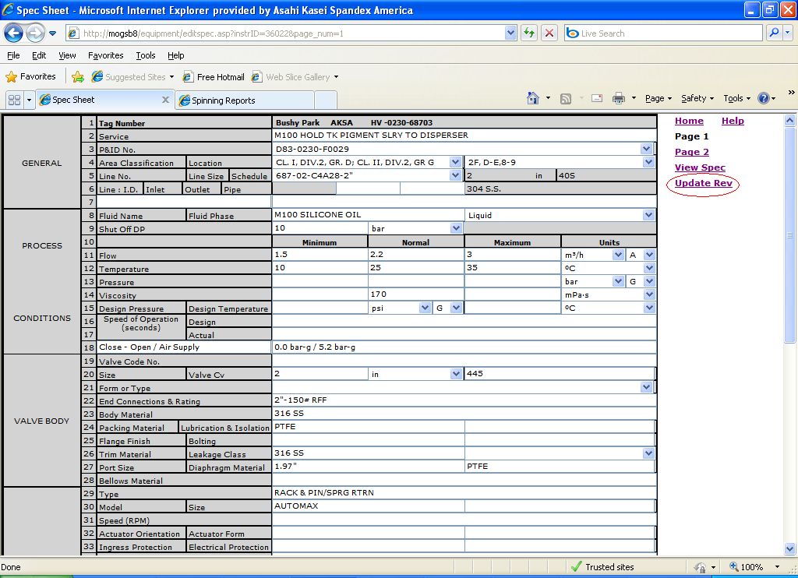
Figure 20

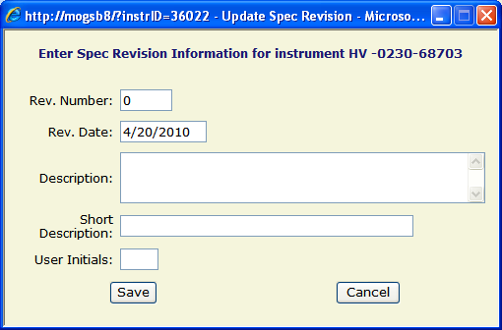
Figure 21

This form automatically increments the highest revision number existing in the database for the selected instrument and displays that as the default. If no revision information exists for this instrument, it defaults to “0”. This value is modifiable. Likewise, the revision date defaults to the current date, but is also modifiable. The user should enter a detailed description in the “Description” field, explaining the reason for the revision. In the “Short Description” field, this reason should be summarized for display on the spec. The “User Initials” field should contain the initials of the person actually making the changes to the spec data. Click the “Save” button to store the information in the database and close the window or the “Cancel” button to close the window without saving. If the data was saved, the “Edit Spec” page refreshes to display the revision information at the bottom of the form (Figure 22).

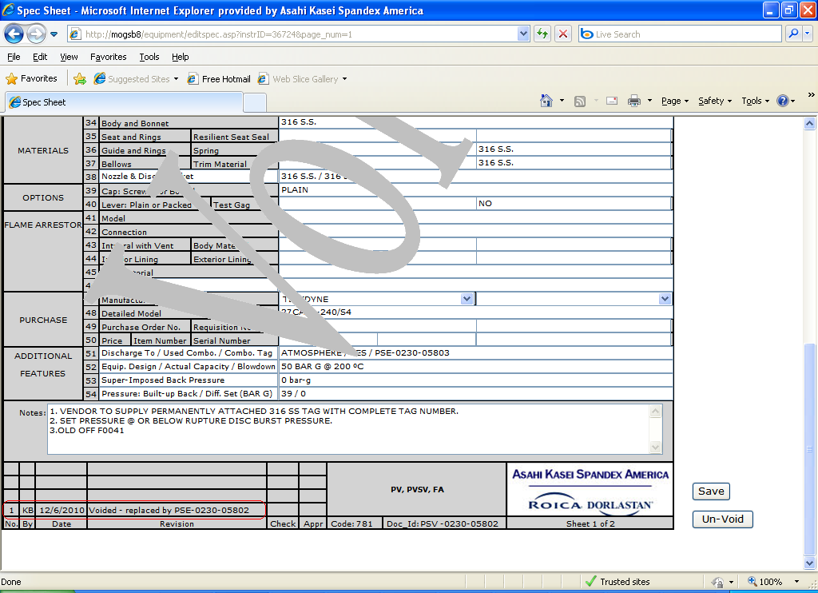
Figure 22

Adding an Instrument
If the user has sufficient privilege, he/she may create a new instrument specification by either manually entering all of the data or by copying an existing spec and modifying it. To begin the process, click the “Add Instrument” button on the main menu. This will open the “Add Instrument” form (Figure 23).

When adding a new instrument, you must first select a plant area. This updates the form with associated parameters that are specific to that plant area (Figure 24). For example, the “Equipment” and “Loop” dropdown lists are filled with items that are assigned to that area. In addition, the form begins automatically building the instrument tag number in the format:

TTTTT-PPPP-NNNNNS

Where TTTTT is the instrument type, PPPP is the plant area, NNNNN is the instrument number, and S is the optional suffix.

Selecting a piece of equipment to which to assign this instrument will automatically fill in the first 3 numbers of the instrument number field as well as the appropriate portion of the tag number field.(Figure 25), but this is not a required field.

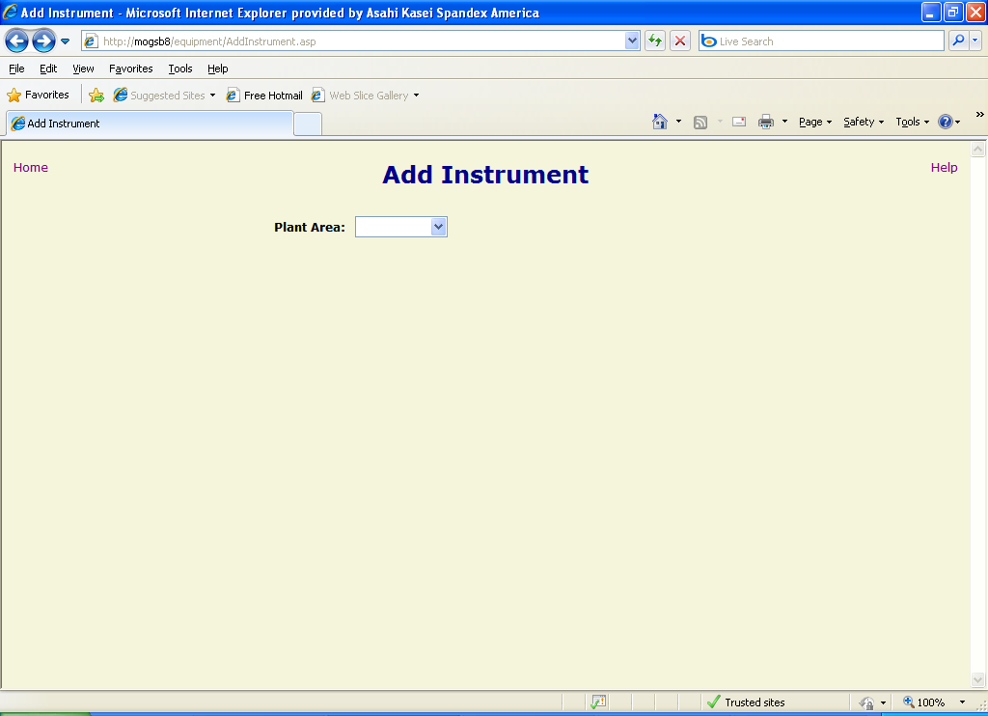
Figure 23

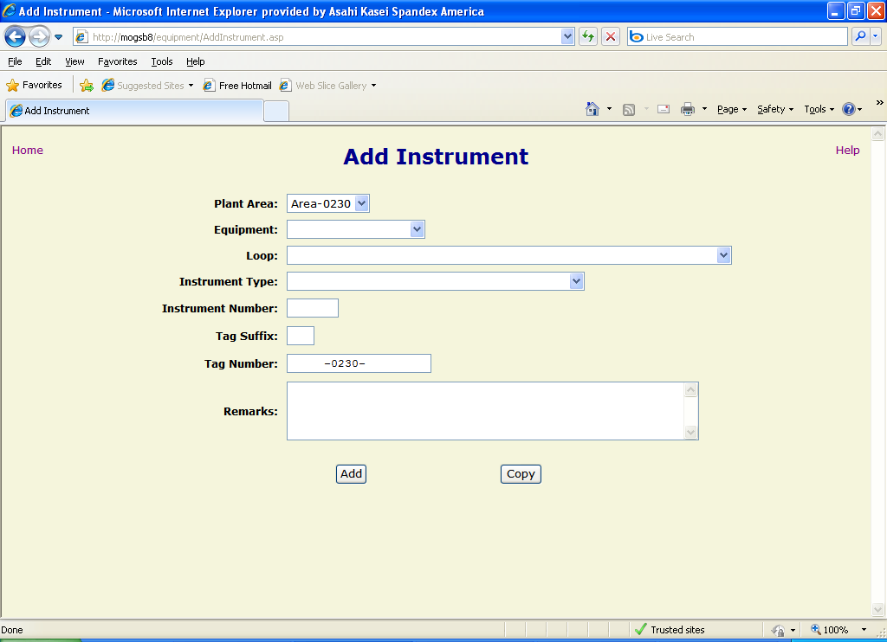
Figure 24

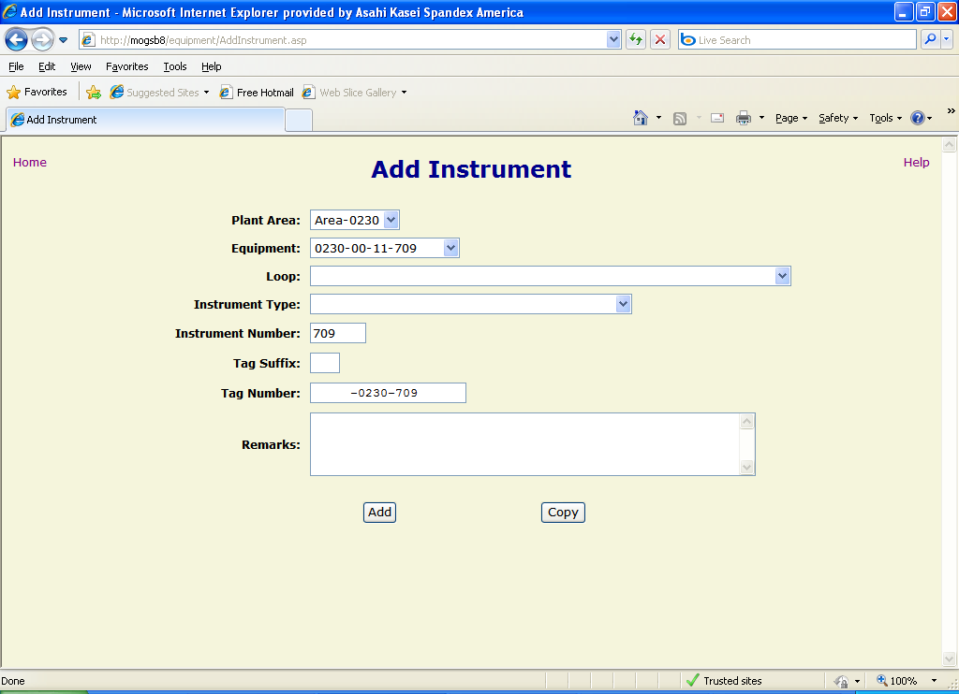
Figure 25
If desired, the instrument can be assigned to a loop by selecting one from the “Loop” dropdown list, but this is not required.

The user must select an instrument type by selecting the appropriate one from the dropdown list. This causes the page to refresh and the tag number is updated to show the instrument type chosen (Figure 26).

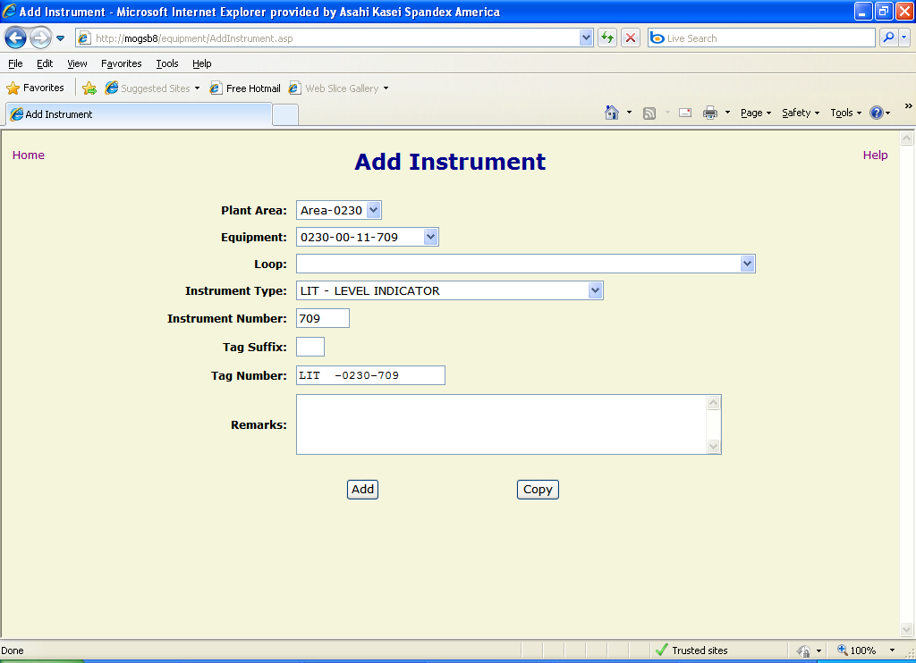
Figure 26

It is important to remember to complete the instrument number by adding the 2-digit identifier to the equipment number that may have been automatically filled in. Alternatively, the instrument number may be manually entered if a piece of equipment was not selected previously. In either case, the instrument number should be 5 digits long. Updating this field will cause the page to refresh and update the tag number to reflect the change (Figure 27).

If needed, a suffix may be entered to indicate multiple occurrences of the same type instrument in similar locations. This suffix is usually a single, capital letter (e.g. A, B, etc.), but may be any alpha-numeric character. This value is automatically appended to the end of the tag number.

The user may also enter a remark about this instrument up to 255 characters. This remark will not be displayed on the spec form.

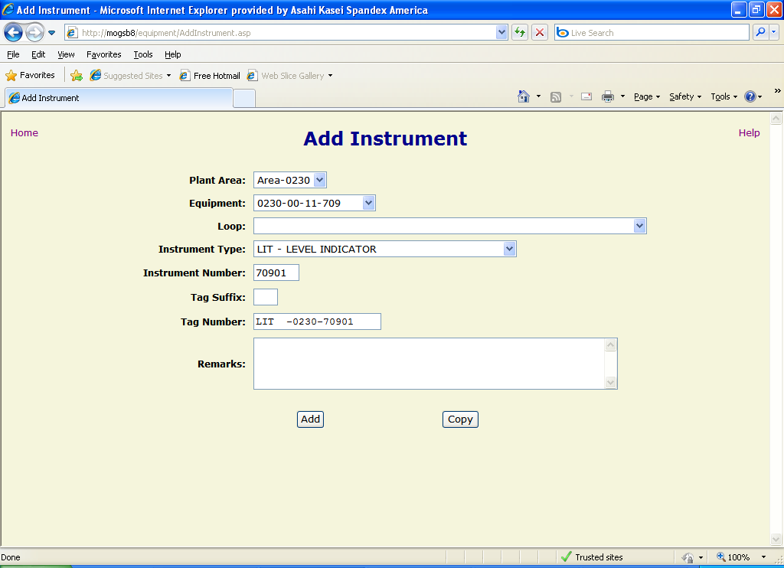
Figure 27

Once all appropriate information has been entered, the user may click the “Add” button to create the instrument, select the desired spec form and then manually enter all of the specification data, or click the “Copy” button to create the instrument and then select an existing instrument spec from which to copy all of the data.

Manually Entering an Instrument Specification
When the user clicks the “Add” button, the application checks to make sure that the specified tag number is not already in use by an active instrument. If it is, an error is displayed (Figure 28) and the user should use the browser’s “Back” button to return to the “Add Instrument” form to correct the tag number and try again.

If the specified tag number does not already exist, a form is displayed to allow the user to select a spec form to assign to the instrument (Figure 29). The selection may default to a specific form based upon the instrument type, but the user may select another if he/she desires. Click the “Show all forms” checkbox to display the complete list of spec forms available. When the desired spec form has been selected, click the “Continue” button to open up the blank instrument spec in edit mode. From here, the user may enter and save all of the appropriate specification data for the new instrument (see Editing an Instrument Spec above).

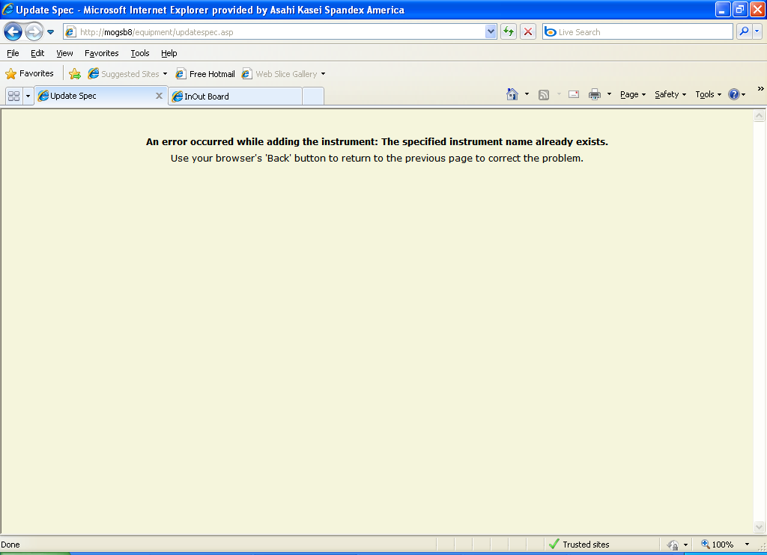
Figure 28

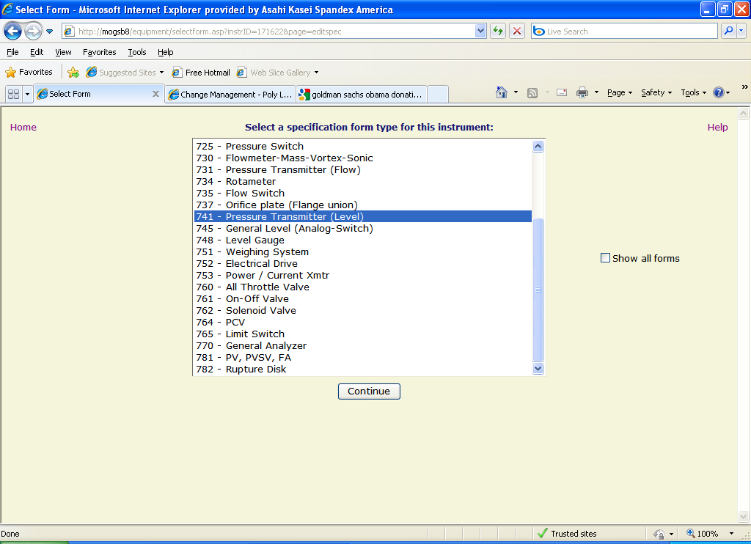
Figure 29

Copying an Instrument Specification
If the user clicks the “Copy” button from the “Add Instrument” page, the application again checks to see if the tag number already exists and displays an error if it does. If not, a form is opened to allow the user to find and select an instrument spec to copy (Figure 30).

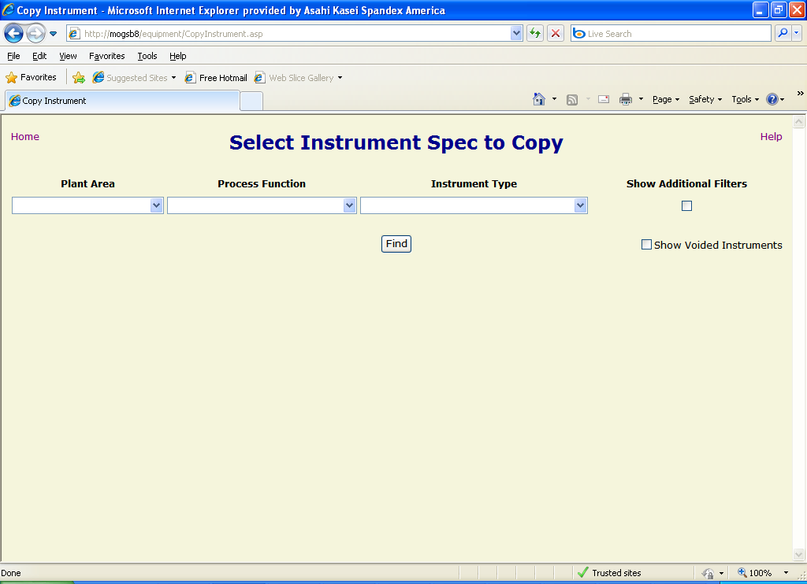
Figure 30

This form operates similarly to the “Find Instrument” form (see Finding an Instrument above) in that the user narrows the search of instruments by choosing filter criteria and specifying whether or not to allow “voided” items. One difference, however, is that the results only include instruments that have an assigned spec form (Figure 31). Once the desired instrument from which to copy is displayed, the user may double-click on it or select it and click the “Copy Spec” button to copy all of the specification information to the new instrument and open up the spec form in edit mode (see Editing an Instrument Spec above)..

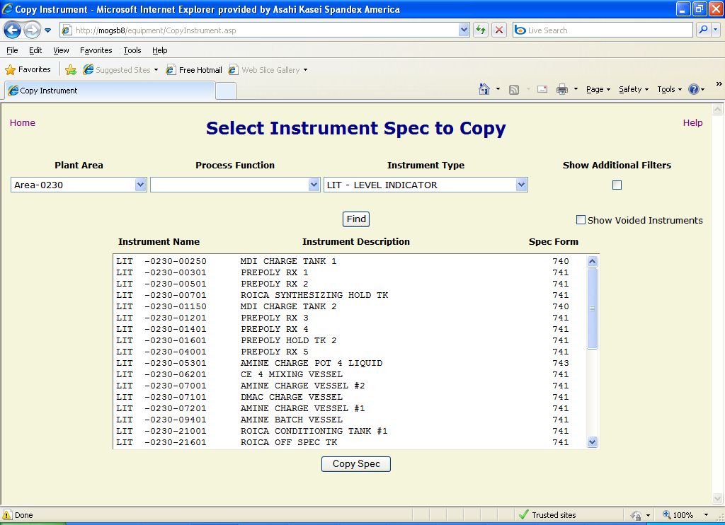
Figure 31

